NURSERY
Boys | WINTER: can be worn all year |  |  | Photo |  | SUMMER: Easter-Oct half term |  | Photo
Shirt | Plain, regulation white school shirt, long or short sleeved. |  |  | 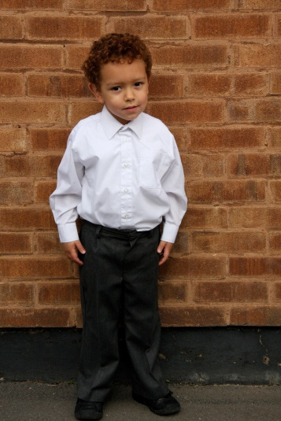 |  | Plain, regulation white school shirt, long or short sleeved. |  | 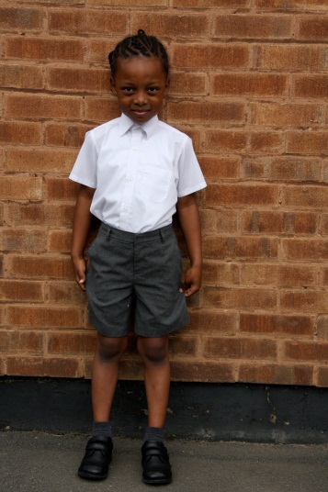
Tie | No tie. |  |  |  |  | No tie.
Trousers/Shorts | Regulation grey school trousers. |  |  |  |  | Regulation grey school trousers or grey school short trousers.
Sweatshirt | Cathedral School navy blue sweatshirt.* |  |  |  |  | Cathedral School navy blue sweatshirt.*
Socks | Grey, white or navy blue socks, ankle or knee length. |  |  |  |  | Grey, white or navy blue socks, ankle or knee length.
Shoes | Flat, black school shoes -preferably with Velcro-below the ankle, no boots or trainers; heels less than 3cm. |  |  |  |  | Flat, black school shoes -preferably with Velcro-below the ankle, no boots or trainers; heels less than 3cm.
Girls | WINTER: can be worn all year |  |  | Photo |  | SUMMER: Easter-Oct half term |  | Photo
Shirt/Blouse | Plain, regulation white, school shirt or blouse, long or short-sleeved. |  |  | 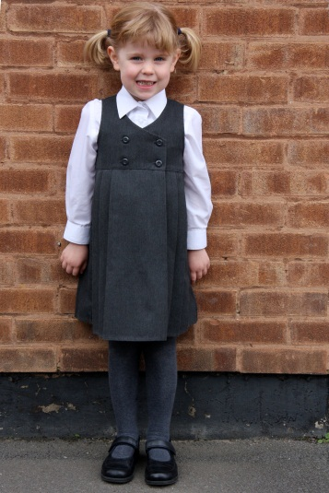 |  | Plain, regulation white, school shirt or blouse, long or short-sleeved. |  | 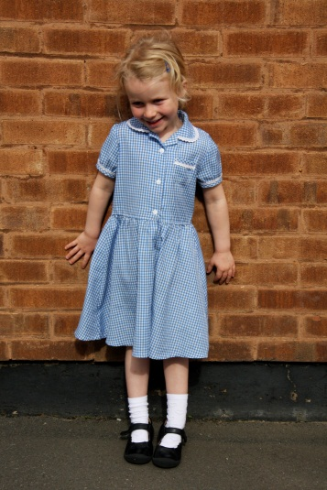
Tie | No tie. |  |  |  |  | No tie.
Skirt/Dress/ Trousers | Regulation, knee-length, grey skirt or pinafore dress or regulation grey school trousers. |  |  |  |  | Regulation, knee-length grey skirt, pinafore dress or trousers (as winter) or blue & white plain striped or plain checked dress.
Sweatshirt | Cathedral School navy blue sweatshirt.* |  |  |  |  | Cathedral School navy blue sweatshirt.*
Socks/Tights | Grey, white or navy blue knee length socks; grey or navy blue tights. |  |  |  |  | White ankle socks with summer dress. Grey, white or navy blue knee length socks or grey or navy blue tights with winter uniform.
Shoes | Flat, black school shoes -preferably with Velcro-below the ankle, no boots or trainers; heels less than 3cm. |  |  |  |  | Flat, black school shoes -preferably with Velcro- or black or white sandals (no open toed sandals or sling backs); heels less than 3cm.
PE Kit | None required for Nursery
Bags & Other Items | School bag: available from school or own selection - small and plain, similar to schools own.*  For emergencies/accidents, an additional small bag (not carrier/plastic bag) may be brought in with a change of clothes, handkerchief/tissues. When determining quantities of uniform needed, bear in mind that any such emergency bag will be left at school.
*available from school office
INFANTS: RECEPTION TO YEAR 2
Boys |  | WINTER: can be worn all year | Photo |  | SUMMER: Easter-Oct half term |  | Photo
Shirt |  | Plain, regulation white school shirt, long or short sleeved. | 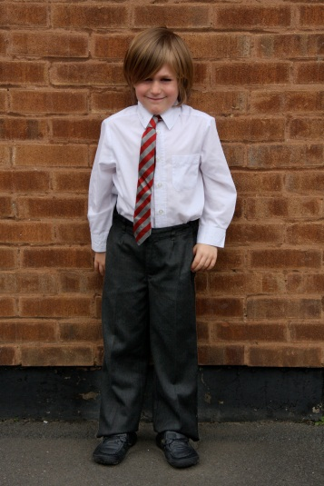 |  | Plain, regulation white school shirt, long or short sleeved. |  | 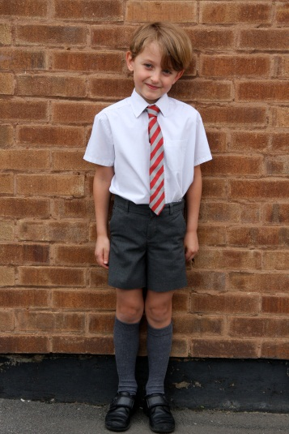
Tie |  | Red/grey school tie.* |  |  | Red/grey school tie.*
Trousers/Shorts |  | Regulation grey school trousers. |  |  | Regulation grey school trousers or grey school short trousers.
Sweatshirt |  | Cathedral School navy blue sweatshirt.* |  |  | Cathedral School navy blue sweatshirt.*
Socks |  | Grey, white or navy blue socks, ankle or knee length. |  |  | Grey, white or navy blue socks, ankle or knee length.
Shoes |  | Flat, black school shoes -preferably with Velcro-below the ankle, no boots or trainers; heels less than 3cm. |  |  | Flat, black school shoes -preferably with Velcro-below the ankle, no boots or trainers; heels less than 3cm.
Girls |  | WINTER: can be worn all year | Photo |  | SUMMER: Easter-Oct half term |  | Photo
Shirt/Blouse |  | Plain, regulation white, school shirt, long or short-sleeved. | 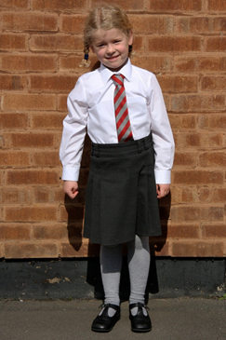 |  | Plain, regulation white, school shirt or blouse, long or short-sleeved. |  | 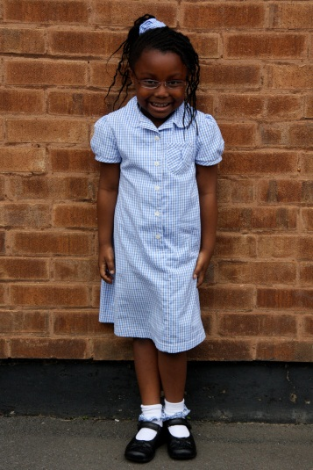
Tie |  | Red/grey school tie.* |  |  | Red/grey school tie.*
Skirt/ Dress/Trousers |  | Regulation, knee length, grey skirt or pinafore dress or regulation grey school trousers. |  |  | Regulation, knee length, grey skirt, pinafore dress or trousers (as winter) or blue & white plain striped or plain checked dress.
Sweatshirt |  | Cathedral School navy blue sweatshirt.* |  |  | Cathedral School navy blue sweatshirt.*
Socks/Tights |  | Grey, white or navy blue knee length socks; grey or navy blue tights. |  |  | White ankle socks with summer dress. Grey, white or navy blue knee length socks or grey or navy tights with winter uniform.
Shoes |  | Flat, black school shoes -preferably with Velcro-below the ankle, no boots or trainers; heels less than 3cm. |  |  | Flat, black school shoes -preferably with Velcro- or black or white sandals (no open toed sandals or slingbacks); heels less than 3cm.
PE Kit |  | 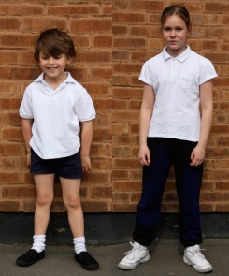  Plain navy blue cotton shorts, plain white cotton short sleeved t-shirt or polo shirt, black plimsolls.  Plain navy blue, black or grey hoodless tracksuit (optional) for outdoor PE.  Indoor PE is done in bare feet and during outdoor PE uniform socks or short white socks can be worn.  Girls wearing tights need socks for PE.
Bags & Other Items |  | School bag: available from school or own selection - small and plain, similar to school’s own.*
*available from school office

JUNIORS: YEARS 3 TO 6
Boys |  | WINTER: can be worn all year | Photo | SUMMER: Easter-Oct half term | Photo
Shirt |  | Plain, regulation white school shirt, long or short sleeved. | 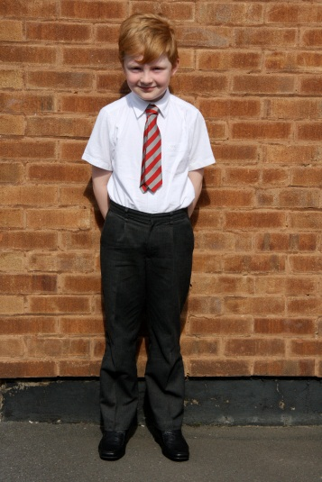 | Plain, regulation white school shirt, long or short sleeved. | 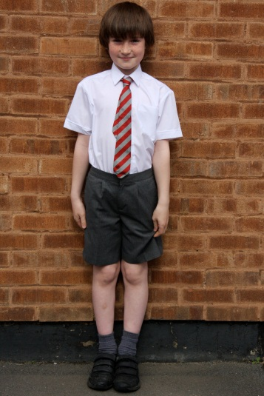
Tie |  | Red/grey school tie.* |  | Red/grey school tie.*
Trousers/Shorts |  | Regulation grey school trousers. |  | Regulation grey school trousers or grey school short trousers
Sweatshirt |  | Cathedral School red sweatshirt.* |  | Cathedral School red sweatshirt.*
Socks |  | Grey, white or red socks, ankle or knee-length. |  | Grey, white or red socks, ankle or knee-length.
Shoes |  | Flat, black school shoes -preferably with Velcro-below the ankle, no boots or trainers; heels less than 3cm. |  | Flat, black school shoes -preferably with Velcro-below the ankle, no boots or trainers; heels less than 3cm.
Girls |  | WINTER: can be worn all year | Photo | SUMMER: Easter-Oct half term | Photo
Shirt/Blouse |  | Plain, regulation white, school shirt, long or short-sleeved. | 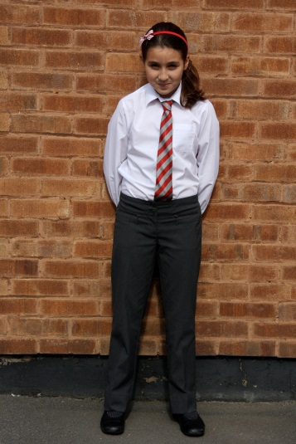 | Plain, regulation white, school shirt, long or short-sleeved. | 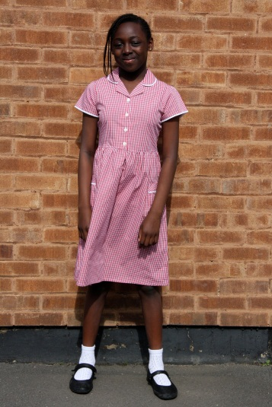
Tie |  | Red/grey school tie.* |  | Red/grey school tie.*
Skirt/ Dress/Trousers |  | Regulation, knee-length grey skirt or pinafore dress or regulation grey school trousers. |  | Regulation, knee-length grey skirt, pinafore dress or trousers (as winter) or red & white plain striped or plain checked dress.
Sweatshirt |  | Cathedral School red sweatshirt.* |  | Cathedral School red sweatshirt.*
Socks/Tights |  | Grey, white or red knee length socks; grey or red tights. |  | White ankle socks with summer dress. Grey, white or red knee length socks or grey or red tights with winter uniform.
Shoes |  | Flat, black school shoes -preferably with Velcro-below the ankle, no boots or trainers; heels less than 3cm. |  | Flat, black school shoes -preferably with Velcro- or black or white sandals (no open toed sandals or slingbacks); heels less than 3cm.
PE Kit  Swimming (Year 4) |  | 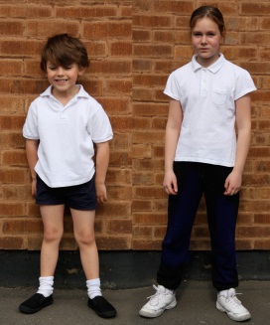  Plain navy blue cotton shorts, plain white cotton short sleeved t-shirt or polo shirt, plimsolls or black or white trainers (optional).  Plain navy blue, black or grey hoodless tracksuit (optional) for outdoor PE.  Indoor PE is done in bare feet and during outdoor PE uniform socks or short white socks can be worn. Girls wearing tights need socks for PE.  Plain black or navy swimsuit/trunks, swimming cap (any colour) and goggles (optional) in plain bag.
Bags & Other Items |  | School bag: available from school or own selection - small and plain, similar to school’s own.*
*available from school office
 | GENERAL GUIDANCE
 | Uniform Changes in different years | The key changes in uniform as children progress through the school are:  - Nursery & Infants: school colour is navy blue/Juniors: school colour is red.  - Infants: require ties to be worn and need PE kit.  - Juniors: switch to red school colour – sweatshirt, dresses, socks, tights, bags and other accessories change accordingly.
 | General Uniform Guidance | - All items including shirts, trousers, shoes, plimsolls and trainers should be plain, regulation school uniform standard items with no logos, embellishments or additional design or fashion elements.  - It is essential that every item should be named, as most items look alike. PE items should be kept in a named drawstring bag (not a carrier or plastic bag); please ensure a small bag is used.  - Trousers and short trousers should be regulation with no side patch pocket, ie. not combat style.  - Shoes should be plain, flat, black school shoes – no boots, trainers, or open toed shoes, no logos. Heels less than 3cm.  - There is no requirement for children to arrive at school wearing their Cathedral School sweatshirt; it depends on the weather.
 | Bags and Other Items | - Bags should not contain any snacks. Toys are not to be brought in for ‘Show and Tell’ unless instructed by the class teacher.  - Bag should contain a clear plastic water bottle with your child’s name clearly marked.
 | Hair, Jewellery, Mobile Telephones, etc | - Pupils’ shoulder length or long hair should be tied back. Hair bands and ‘bobbles’ should be in school colours e.g. navy blue or red or grey or black or white.  - Large claw style clips are not allowed. Extreme hairstyles and hair gel/mousse are not permitted.  - Infant children may not wear jewellery or watches. Junior children may not wear jewellery but may wear a watch that does not ‘beep’.  - Stud earrings for pierced ears are allowed.  - Children are not permitted to bring mobile telephones to school. However, the Head Teacher has exercised her discretion to allow Years 5 & 6 to do so if telephones are labelled and handed in on arrival.  - None of the following are allowed; nail varnish, make-up, stick-on tattoos.
 | Hot Weather/Summer | - Sun hat: plain white or navy blue [nursery & infants] or plain white or red [juniors] sun hat or school baseball cap.*  - Note that in summer, sun cream must be applied before coming to school as school cannot be responsible for putting it on and so no sun cream to be put in bags.
If in any doubt, please check with the School Office before purchasing.

A list of suggested stockists put together by school parents is available at the end of this document.

STOCKISTS: this is not a comprehensive list but some suggested local or online outlets where parents have found good quality, reasonably priced and appropriate uniform
Items | Cathedral School branded uniform
Tie  Sweatshirt  Baseball cap  Book bag  Rucksack | Red/grey: £5  Navy blue or red: Infant, Small, Medium £10; Adult £12  Navy blue or red: £5  Navy blue or red: £6  Navy blue or red: £6 | To order school uniform, please write a note of your requirements and either hand to the class teacher or drop into the school office along with the correct payment in cash or cheque (cheques made payable to “Cathedral Primary School”). Uniform can be picked up on Monday after school or will be left in your child’s bag.  Prices correct as at March 2014. Check the website for any changes.  Second hand uniform is sold at the annual School Fete and at Cathedral Creative.
Items | Store | Nearest Store/Online
All  PE Kit/Tracksuits  Shoes  Trainers | Asda  BHS  Direct Schoolwear  Marks & Spencer (nb. items bought online can be collected from Bankside)  Sainsbury’s  H&M – good quality plain, no logo tracksuits at reasonable prices  Most of the main stockists sell school shoes.  Sports Direct | Old Kent Road/www.asda.co.uk  www.directschoolwear.co.uk  Oxford Street/www.marksandspencer.co.uk  Clarks and Start-rite are the main brands of school shoes.

